Compliance Acceptance Testing

Definition
# Source: AI Source: Provided by: [Data Path: Persons Table -> ID Column: 1, Name_En Column: Motasem Essam] -> From: [ChatGPT] on [8/23/2025]
Compliance Acceptance Testing is performed to ensure that a software system adheres to internal company policies, standards, and guidelines, as well as any external regulations or best practices adopted by the organization.
It focuses on organizational or industry-specific compliance, rather than legal or regulatory enforcement by government authorities.

Objective
# Source: AI Source: Provided by: [Data Path: Persons Table -> ID Column: 1, Name_En Column: Motasem Essam] -> From: [ChatGPT] on [8/23/2025]
- Validate that the system aligns with organizational standards, coding guidelines, security policies, and industry best practices.
- Ensure consistent quality, safety, and security across projects within an organization.

When is it Performed?
# Source: AI Source: Provided by: [Data Path: Persons Table -> ID Column: 1, Name_En Column: Motasem Essam] -> From: [ChatGPT] on [8/23/2025]
- During or after System Testing, and before production release.
- Common in large organizations or industries like banking, healthcare, telecom, where strict internal standards exist.

Who Performs It?
# Source: AI Source: Provided by: [Data Path: Persons Table -> ID Column: 1, Name_En Column: Motasem Essam] -> From: [ChatGPT] on [8/23/2025]
- Internal QA teams, compliance officers, or audit teams.
- Sometimes involves third-party auditors for certification.

What Does It Cover?
# Source: AI Source: Provided by: [Data Path: Persons Table -> ID Column: 1, Name_En Column: Motasem Essam] -> From: [ChatGPT] on [8/23/2025]
- Internal security policies (e.g., password complexity, encryption).
- Development standards (e.g., naming conventions, code quality metrics).
- Process compliance (e.g., adherence to Agile/Scrum practices, documentation).
- External frameworks adopted by the company (e.g., ISO 9001, ITIL).

Examples
# Source: AI Source: Provided by: [Data Path: Persons Table -> ID Column: 1, Name_En Column: Motasem Essam] -> From: [ChatGPT] on [8/23/2025]
- A banking application tested for compliance with internal encryption policies.
- A company ensuring that all its web applications follow WCAG accessibility guidelines, even if not legally mandated.
- Software checked for adherence to internal coding standards and CI/CD policies.

✅ Advantages
# Source: AI Source: Provided by: [Data Path: Persons Table -> ID Column: 1, Name_En Column: Motasem Essam] -> From: [ChatGPT] on [8/23/2025]
✔ Ensures organizational quality and security consistency.
✔ Helps maintain brand reputation and trust.
✔ Reduces operational risks.

❌ Disadvantages
# Source: AI Source: Provided by: [Data Path: Persons Table -> ID Column: 1, Name_En Column: Motasem Essam] -> From: [ChatGPT] on [8/23/2025]
✘ Can be time-consuming and resource-intensive.
✘ Often seen as bureaucratic by development teams.
✘ May require specialized audits and training.

✅ Compliance vs Regulatory Acceptance Testing
# Source: AI Source: Provided by: [Data Path: Persons Table -> ID Column: 1, Name_En Column: Motasem Essam] -> From: [ChatGPT] on [8/23/2025]
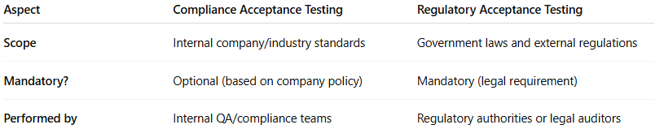
Aspect | Compliance Acceptance Testing | Regulatory Acceptance Testing
Scope | Internal company/industry standards | Government laws and external regulations
Mandatory? | Optional (based on company policy) | Mandatory (legal requirement)
Performed by | Internal QA/compliance teams | Regulatory authorities or legal auditors

